Lab Report: Hospital Network Design and Implementation
Objective
To design and implement a modern hospital network with the following requirements:
- Three routers connecting each floor of the hospital, located in the server room.
- Individual switches for each floor, with departments configured in different VLANs.
- WiFi networks for laptops and phones on each floor.
- Each department equipped with printers.
- All devices to communicate via VLANs and IPs assigned dynamically by DHCP.
- Use OSPF as the routing protocol to advertise routes.
Network Design Overview
Floor and VLAN Details
- 1st Floor:
VLAN 80, Network: 192.168.8.0/24
VLAN 70, Network: 192.168.7.0/24
VLAN 60, Network: 192.168.6.0/24
- 2nd Floor:
VLAN 50, Network: 192.168.5.0/24
VLAN 40, Network: 192.168.4.0/24
VLAN 30, Network: 192.168.3.0/24
- 3rd Floor:
VLAN 20, Network: 192.168.2.0/24
VLAN 10, Network: 192.168.1.0/24
Router Connections
- Router 1 (1st Floor) ↔ Router 2 (2nd Floor) via Serial Link: 10.10.10.0/30
- Router 2 (2nd Floor) ↔ Router 3 (3rd Floor) via Serial Link: 10.10.10.4/30
- Router 1 (1st Floor) ↔ Router 3 (3rd Floor) via Serial Link: 10.10.10.8/30
Network Topology:
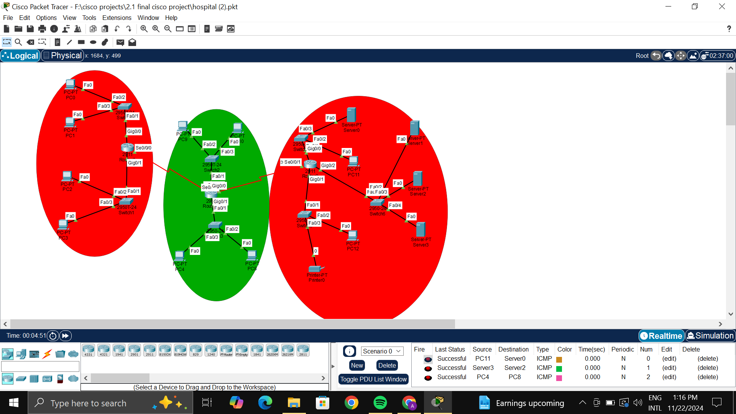
Fig: Hospital Management System Network Design

Last Status
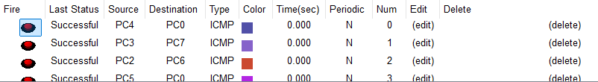

Testing and Verification
- Use the following commands to verify configurations:
  - ping to check connectivity between devices.
  - show vlan brief to verify VLANs on switches.
  - show ip route to confirm OSPF routing.
Results
- All departments are assigned to their respective VLANs.
- Devices dynamically receive IP addresses from DHCP servers.
- Communication between floors and departments works as intended.
- OSPF successfully advertises all routes.
Conclusion
The network design meets all requirements of the modern hospital network, including VLAN segmentation, DHCP dynamic IP allocation, and inter-floor communication via OSPF. This implementation ensures efficient and secure networking for all departments.

